Merighi Test DVD

Usage notes version 1.08 (feb 14 2008) by Luciano Merighi merifon@libero.it

Screenshots go looping on themselves. No “pause key” needed. Use remote to go on desired screenshot.
Be aware that TestDVD is intended for calibration of the DVD’s vision only, not for other sources i.e. videogames or television broadcasts!!!

Luma Chroma menu:

BTB
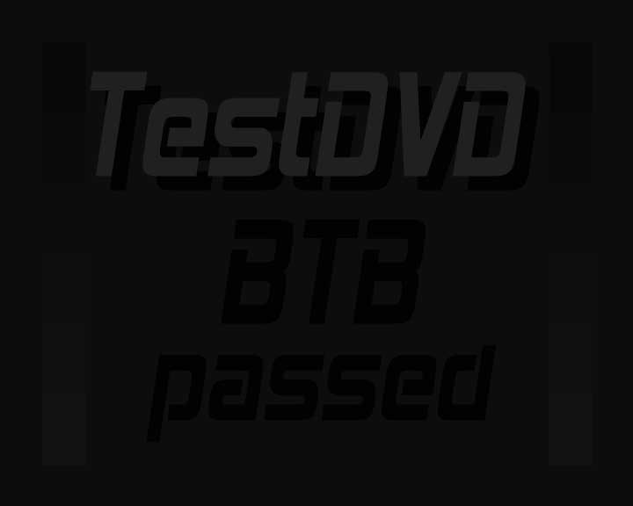 Y digital levels range 0-255

In a system able to display “below 16” levels, rising the brightness control should make visible “BTB passed” over the background. Nice to know, since in normal dvd’s no signal below Y level 16 is present!

Set contrast Blacks Whites
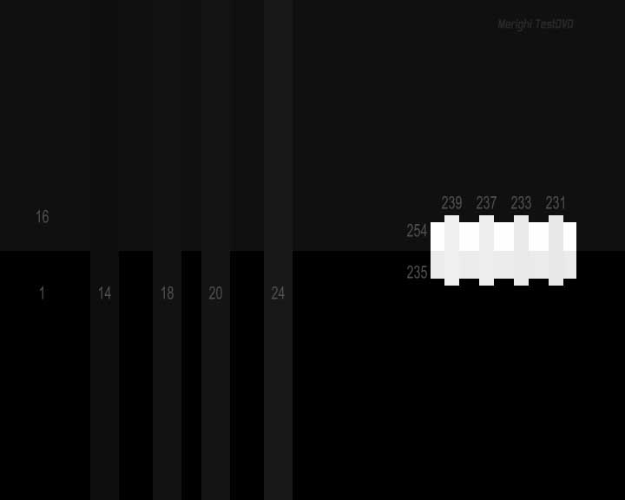 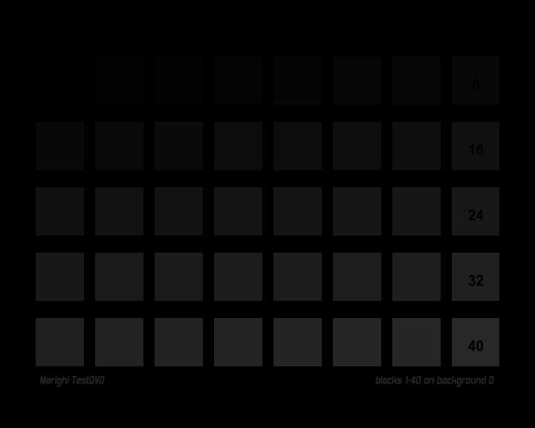 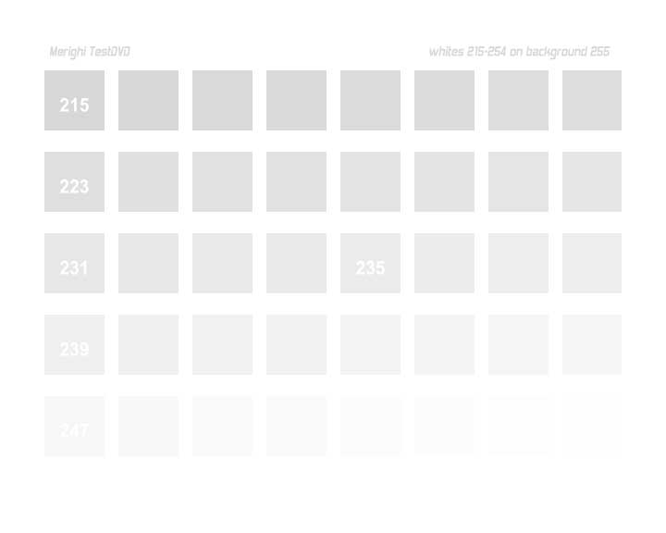 Y digital levels range 0-255

On normal DVD’s, nominal range is 16-235 of digital Y level. 16 means black, 235 means white.
Operate the brightness control to set the “16” upper half background of “set contrast” frame, slightly visible over the “1” area. Check for “18” And 24” columns clearly visible. In the meantime, operate the contrast control to make 239 just a little visible versus 254 and 235.
Then, “blacks” and “whites” screenshot can be used to check how many levels outside CCIR601 Y range 16-235, can the system reach. Further fine adjustments are possible. Since some signal excursions over that limit are possible, a reasonable range could be 16-239.

Luma step Grey ramp
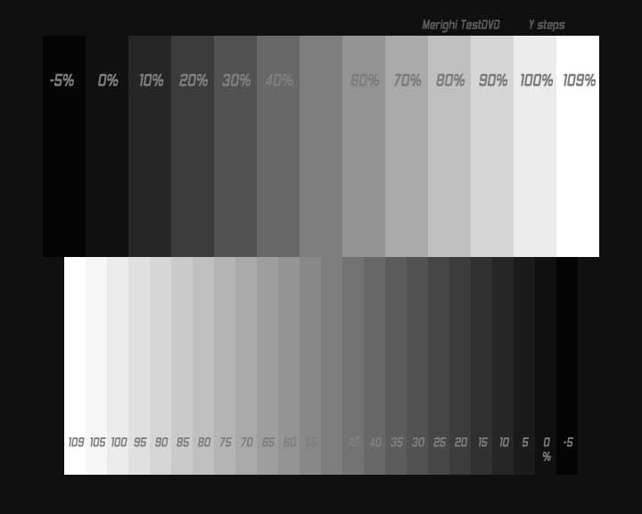  Y digital levels range 0-255

These two screeshots allow to verify results of previous adjustments and if there are some color dominances instead neutral grey. Luma step shows percentage Y levels 0%=16 and 100%=235.
Grey ramp goes from 0 to 255 in two pixel wide colums, leftmost area is 16 and rightmost is 235

Set colors
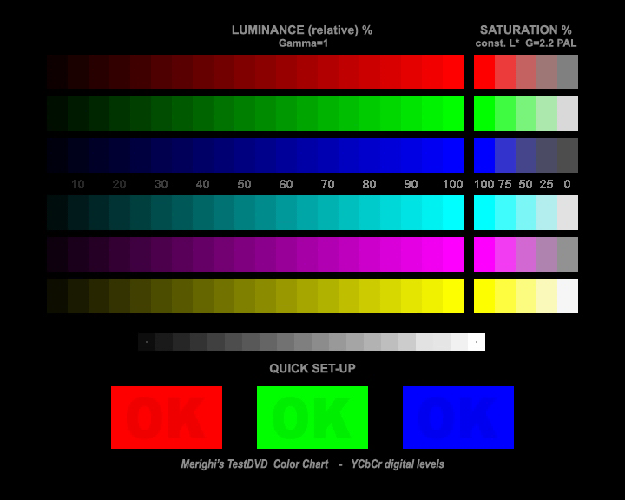 Y digital levels range 16-235 Cb Cr range 16-240

Operate color controls to make 95% levels distinct from 100%

RGB resolution
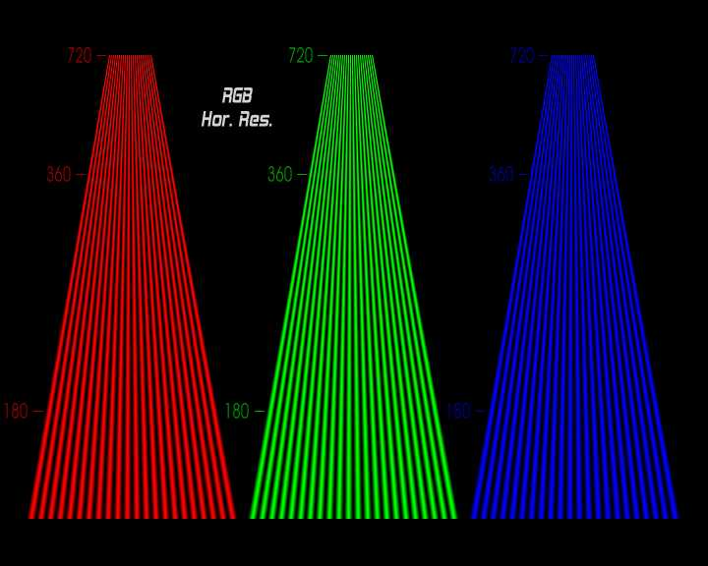

Just to show the lower color resolution due to 4:2:0 subsampling of mpg stream endorsed by PAL DVD’s.

Chroma delay
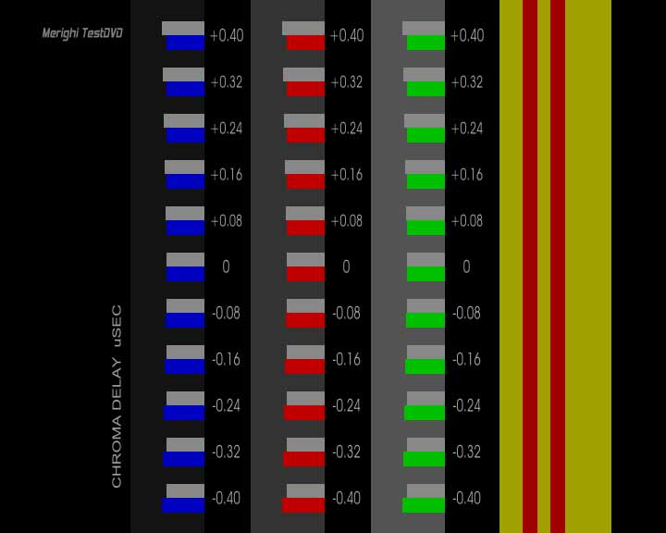

To check if there is delay between Y and chroma components. Color and grey rectangles should be vertical aligned in the left side at 0,00 usec

Chroma Bug
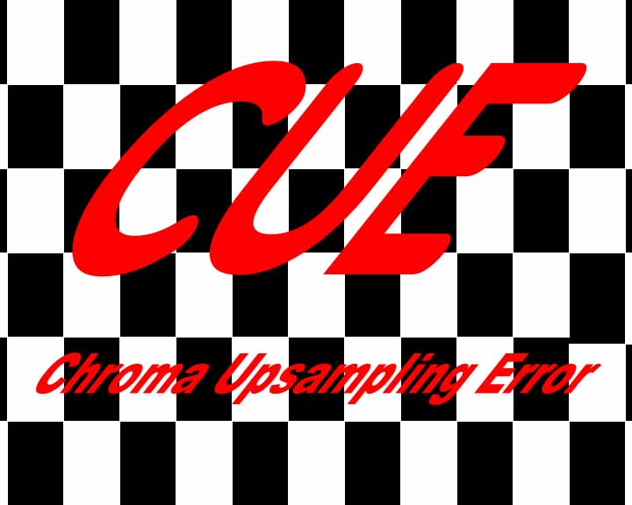
effetto simulato
CUE test, letters should have good edges, not as the example above.

Red, Green, Blue, White, Black screeshot

To check for faulty pixels and display matrix uniformity.

Measures menu:

Horizontal lines vertical lines Fine grid
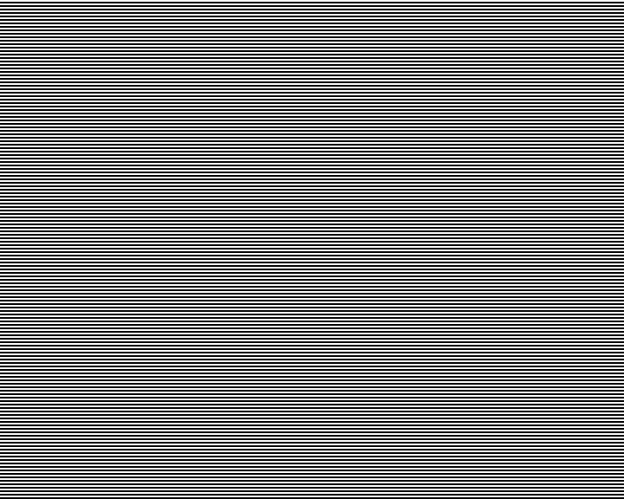

Vertical and Horizontal two pixel wide lines. They allow to see the effect of a given rescaling process. They should appear as more regular as possible.

Horizontal resolution Vertical resolution
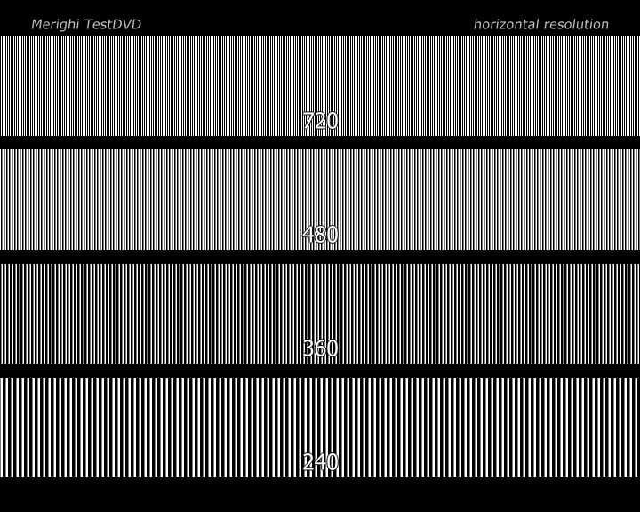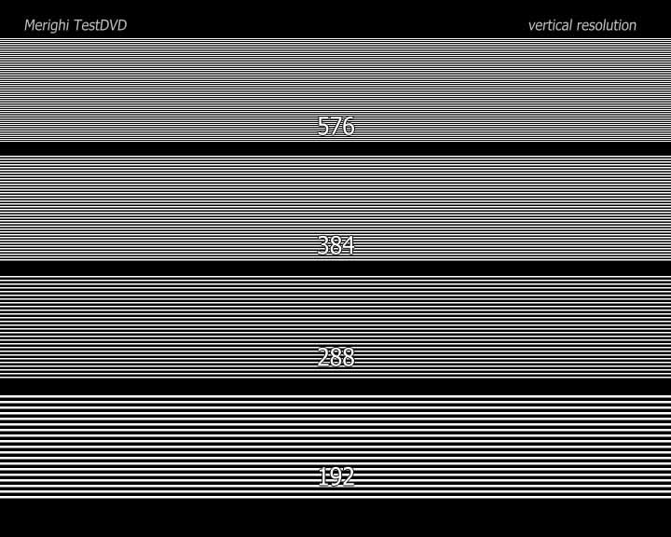

Testing for how many “lines of television resolution” a given system can handle.

Pixel crop Grid Squares
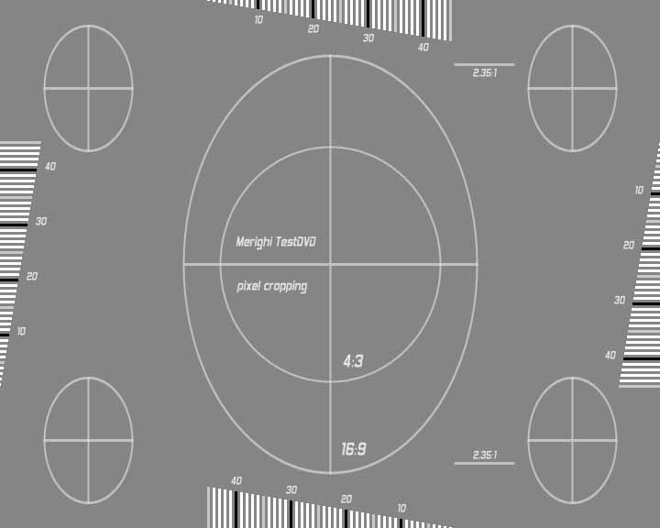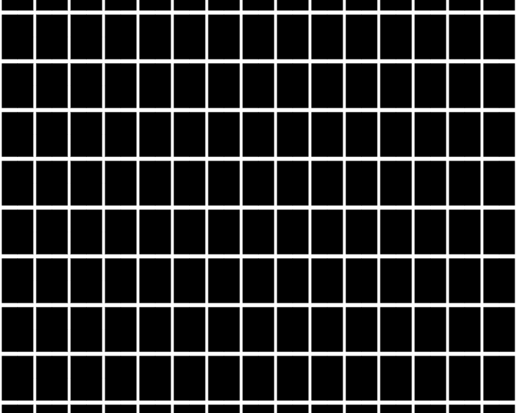

How many pixels are cutted-away and screen aspect regularity or image distortion test.

Scope bars Scope burst
 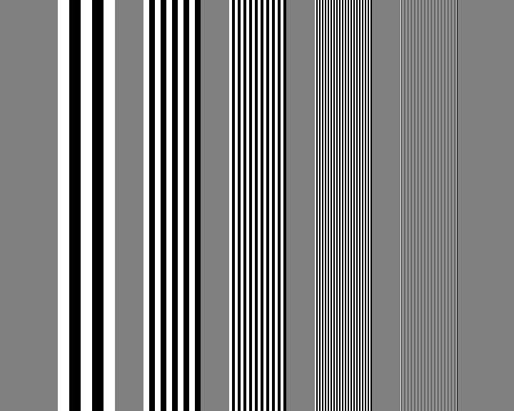 Y digital levels range 16-235

These signals are useful when using a oscilloscope to see the analog output wave form.

Motion menu:

Pendulum: video mode, film mode, alternate flag
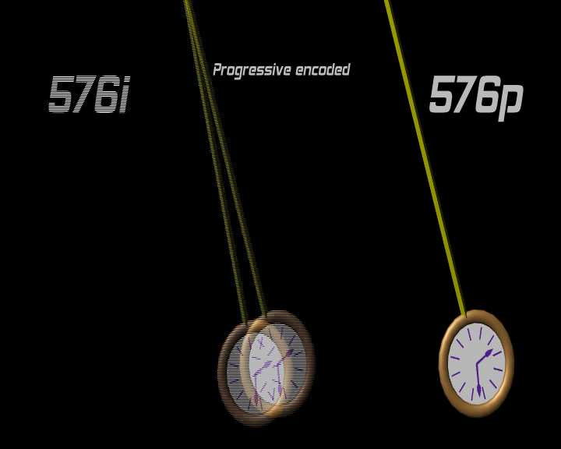

Various flag pendulum sequences. A good deinterlacer should analyze the content of frame (motion adaptive) and disregard the flag. No combing should be showed anytime and no necessarily field interpolation should be activated. Observation of different sequences could permit comparision between deinterlacers.

Jaggies
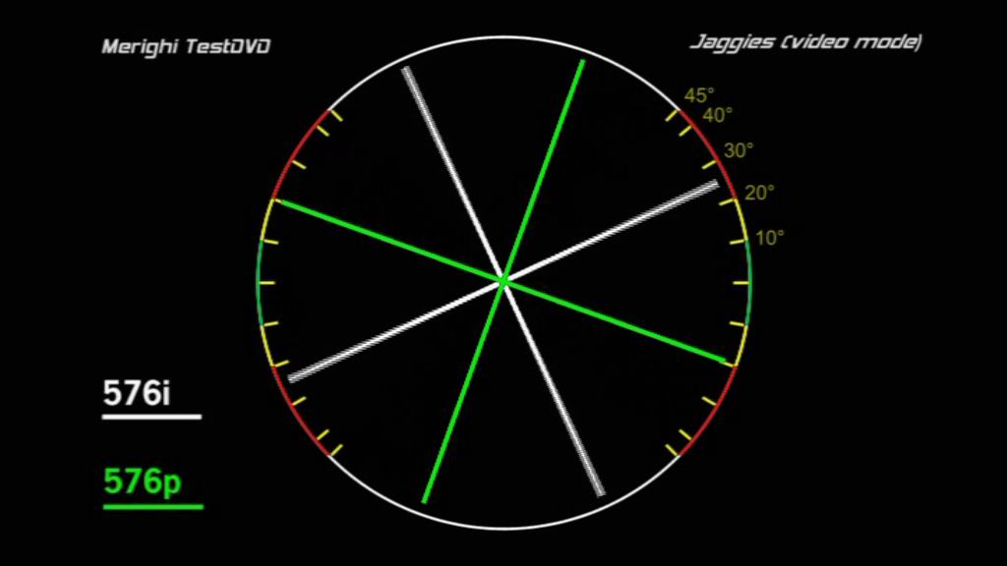

Rotating lines should show jaggies just in the low angles area.

Flag
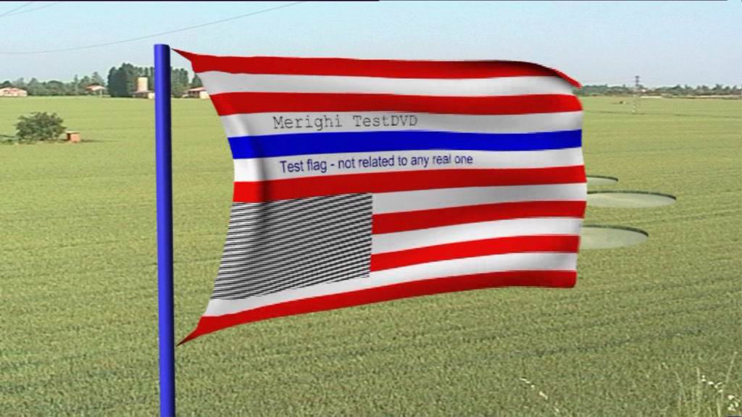

Another test to check deinterlacer capability to handle jaggies. Look at the border of big colored lines and thin b/w ones.

Moving bars
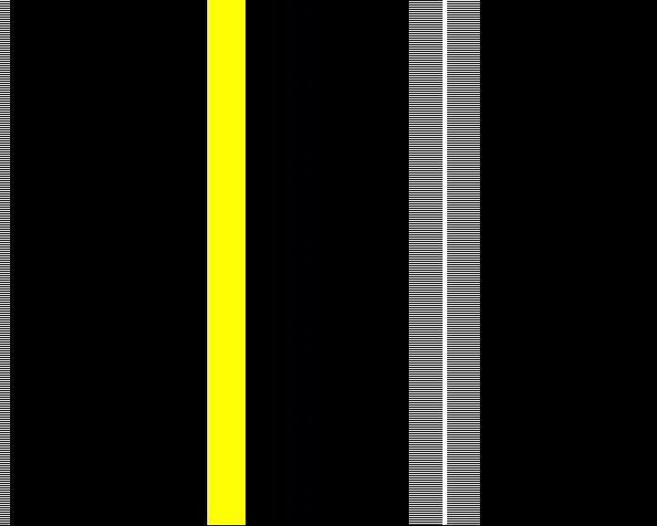

Moving bars should not show any break-up. Sometimes, motion adaptive deinterlacers can be fooled by the presence of interlaced and progressive bars and switch randomly from video to film mode.

Probe greys menu:

To be used with probes and measuring systems.

Screenshots in range from 0% to 100% (Y 16-235).

Probe colors menu:

To be used with probes and measuring systems.

Series of RGBCMY singles screenshots at different saturation.
On CIE-1936 chart, they are at regular distance from white to fully saturated colors.
Reference are: PAL gamut, gamma 2.2 and D65 reference white.

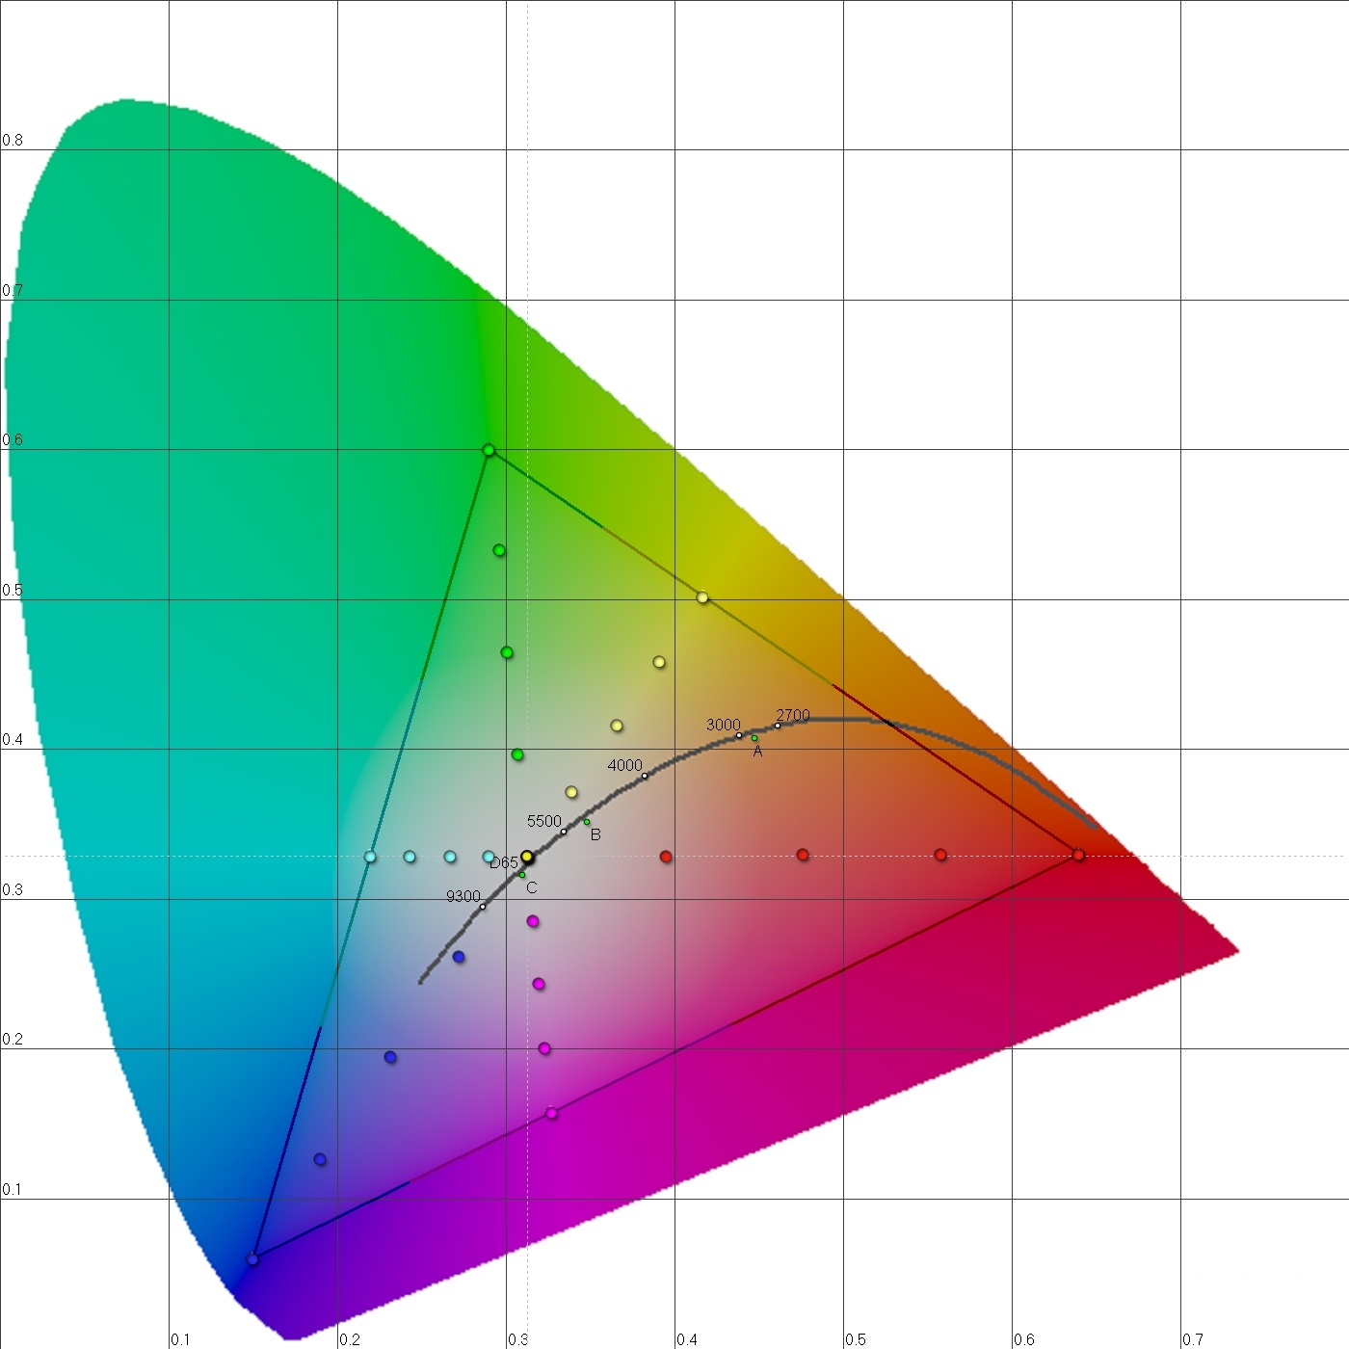

gamut: PAL (EBU 3213 /ITU)
gamma: 2.2
white: D65

